What is difference between centralized server and distributed server in github
In the context of GitHub, understanding the difference between centralized servers and distributed servers involves contrasting two distinct approaches to version control and collaboration:
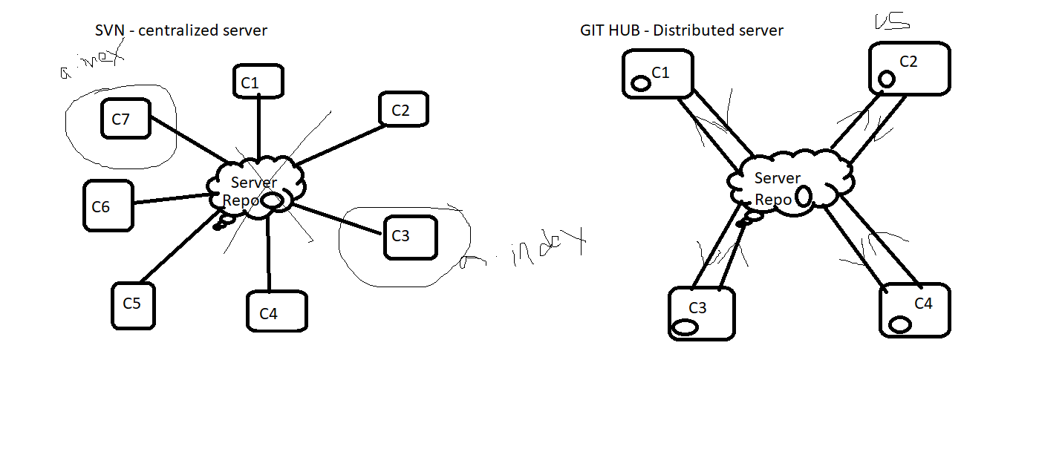

1. Centralized Server
- Definition: In a centralized system, there is a single central server that hosts the repository, and all developers directly interact with this central repository.
- Workflow:
  - Developers check out (pull) code from the central server.
  - All changes are committed back to this single server.
- Pros:
  - Simpler to understand and manage for small teams.
  - Central point of truth.
- Cons:
  - If the central server goes down, development halts.
  - Requires continuous network access to the server for operations like commit, update, or merge.
- Example: Systems like Subversion (SVN) or Perforce follow this model.

2. Distributed Server
- Definition: In a distributed system, every developer has a complete copy of the repository (including the full history) on their local machine. This is the model Git (and thus GitHub) uses.
- Workflow:
  - Developers clone the repository, creating a local copy of the entire codebase.
  - Changes can be made and committed locally without needing a central server.
  - Changes are shared between developers by pushing to or pulling from a shared repository (e.g., GitHub, GitLab).

- Pros:
  - Fully offline work: Developers can commit and view history without a network connection.
  - Redundancy: No single point of failure since every developer has the full repository.
  - Easier branching and merging.
- Cons:
  - Requires more disk space because each user has a complete copy of the repository.
  - More complex workflows can be overwhelming for beginners.
- Example: Git, Mercurial.

GitHub Context
- GitHub uses the distributed model of Git. It acts as a remote, shared repository where developers push and pull changes. However, every collaborator has their own complete copy of the repository on their local machine.
Key Differences:
Feature | Centralized Server | Distributed Server
Repository Location | Single central server | Every user has a full copy
Offline Capability | Limited or none | Full offline capabilities
Fault Tolerance | Server downtime halts work | Work continues locally
Collaboration | Requires constant connection | Push and pull changes as needed
Performance | Slower due to network reliance | Faster local operations

What is Version Control?
- Tracks changes in code over time.
- Helps in collaboration among developers.
- Allows rollback to previous versions if needed.

Why Use GitHub for Version Control?
- Cloud-based repository hosting for Git.
- Facilitates team collaboration with branching and merging.
- Provides access control and security features.
- Supports integration with CI/CD pipelines.

Key Features of GitHub
✅ Repositories: Store and manage your project files.
✅ Branches: Work on new features without affecting the main code.
✅ Commits & History: Track every change made to the codebase.
✅ Pull Requests: Review and merge changes seamlessly.
✅ Issues & Discussions: Manage bugs and project tasks effectively.
✅ GitHub Actions: Automate workflows and CI/CD.
✅ Forking & Cloning: Contribute to open-source projects easily.

Benefits of Using GitHub
Faster and efficient collaboration.
Secure backup of code.
Easy integration with DevOps tools.
Enables open-source contributions.
Process: From Local to Remote
1) create New Project
2) Create Local(git) Repository
3) Add files to Staging
4) Commit Changes to local(git) Repository
5) Push changes to master branch Remote Repository(GitHub)

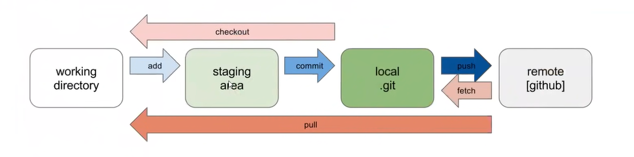
Process: From Remote To Local
1) Clone Remote Repo to Local Repo (Working directory)
2) Import project from git to workspace
2) Add/modify features/code/Test cases
3) Create new branch in Remote Repo(Github) using Eclipse
4) Add file/s to staging
6) Commit changes to Local Rep(git)
7) Push changes to Remote Rep(Github) from new branch
8) Request PR(Pull Request) for review code

Git Bash Basic Command

1. Working with Directories and Files
Command | Description
pwd | Displays the present working directory (current path).
ls | Lists all files and folders in the current directory.
cd folderName | Changes into the specified folder (directory).
cd .. | Moves one level up in the folder structure.
mkdir folderName | Creates a new folder with the specified name.
cd directory1/directory2 | Moves into nested folders in a single command.
touch fileName | Creates a new file with the given name.
cat fileName | Displays content of a file.
vim fileName | Opens the file in VIM editor (press i to insert text, Esc, then :wq! to save and exit).

2. Git Initialization and Status
Command | Description
git init | Initializes an empty Git repository in the current folder.
git status | Shows the current state of the working directory and staging area.

3. Staging Files
Command | Description
git add filename | Moves the file from Unstaged ➡️ Staged state.
git add . | Stages all modified/created files in the folder.
git ls-files | Shows the list of all staged files.
git rm --cached filename | Removes the file from Staged ➡️ Unstaged, but does not delete it from disk.

4. Committing Changes
Command | Description
git commit -m "your message" | Commits the staged files with a message.
git commit -a -m "your message" | Directly commits already tracked (modified) files skipping git add.

5. Viewing Commit History
Command | Description
git log | Shows detailed commit history.
git log --oneline | Shows commit messages in one line per commit (compact view).

6. Working with Remote Repositories
Command | Description
git clone <repo_url> | Clones a remote Git repository into the local machine.
git push origin main | Pushes changes from local main branch to the remote.
git pull origin main | Pulls the latest changes from remote main branch to local.

7. Branching
Command | Description
git branch | Lists all branches in the repository.
git branch <branchName> | Creates a new branch.
git checkout <branchName> | Switches to the specified branch.

8. Merging Branches (Step-by-Step)
Goal: Merge feature-branch into main

➤ Step 1: Switch to main branch
git checkout main

➤ Step 2: Merge the feature-branch into main
git merge feature-branch

➤ Step 3: Resolve any merge conflicts (if any), then:
git add .
git commit -m "Merged feature-branch into main"

